

**UNIVERSITI TEKNOLOGI MARA (UiTM), KEDAH, KAMPUS SUNGAI PETANI SCHOOL OF INFORMATION SCIENCE COLLEGE OF COMPUTING, INFORMATICS, AND MATHEMATICS**

[DIPLOMA IN LIBRARY INFORMATICS]

(CDIM 144)

[PROGRAMMING FOR LIBRARIES]

(IML208)

**INDIVIDUAL PROJECT: LIBRARY RENEWAL SYSTEM**

**PREPARED BY:**

IQRAM HAZIQUE BIN SULAIMAN

(2023615016)

**PREPARED FOR:**

MOHD FIRDAUS BIN MOHD HELMI

**SUBMISSION DATE:**

18th DECEMBER 2024

**Project Name**: Library Renewal System

This project is an idea that comes from a common problem amongst librarian albeit a long time ago, circulation services and or processes are conducted manually and it pretty much caused quite a heavy load on librarians and staffs, so I wanted to create this renewal system that could at least aid in lessening their burden.

**File name** : dialib.py

**Prompt Data :**

I have set the data prompt to be the title of the borrowed book since it is the most likely access points in the context of library, the borrower’s initials (e.g. Farhan Bin Khalid = F.K.) to create a standardized naming convention for a much more organized record, contact number so the librarian can call them in case of anything, and borrowed date the date when the book is borrowed to come up with the due date.

1. Book Title



1. Borrower’s Initials



1. Contact no



1. Borrowed Date



**Function :**

1. Create data/ Add book

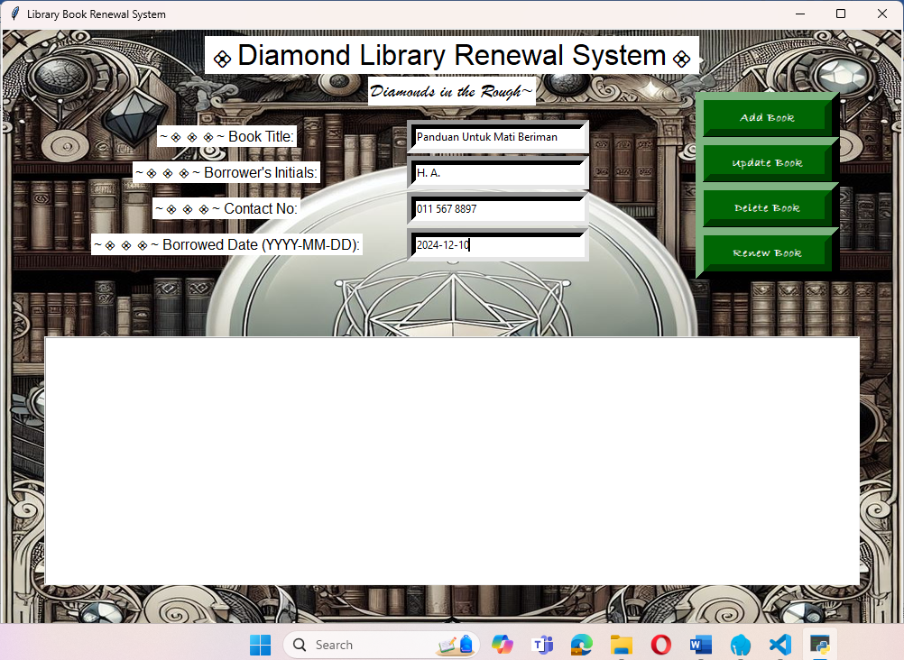

1. Read data/ Display

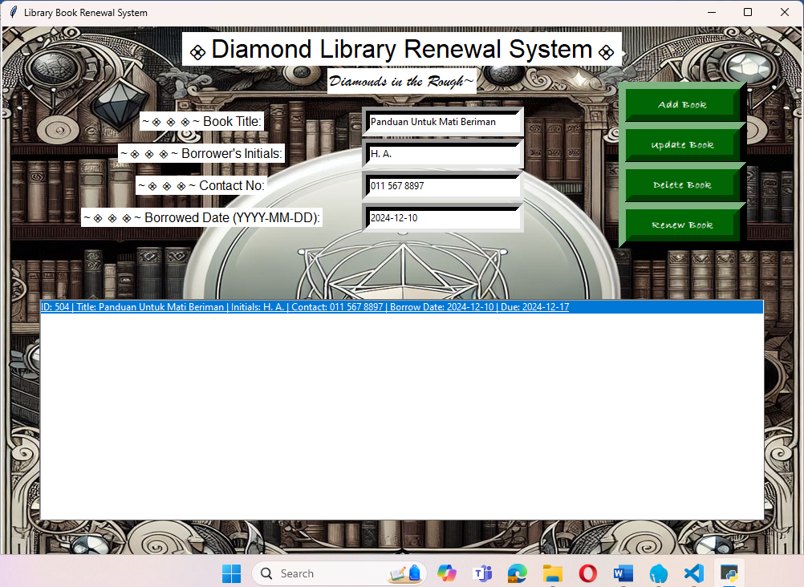

1. Update data/ Update book



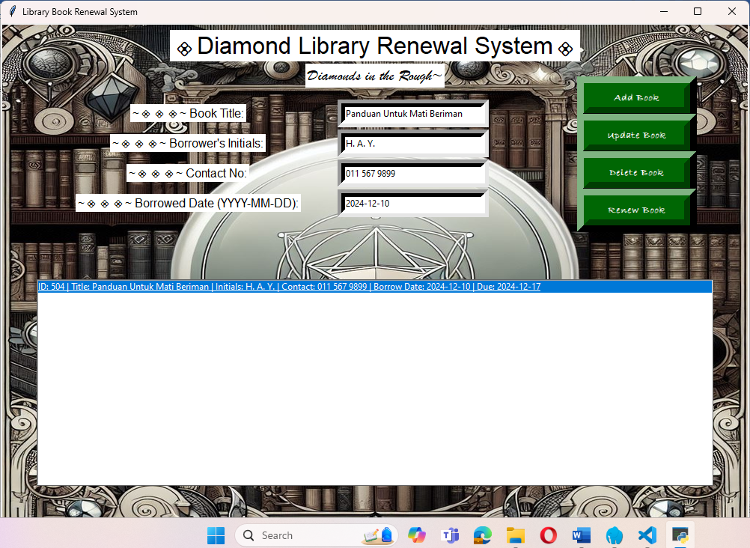

1. Delete existing data/ Delete existing borrowing record

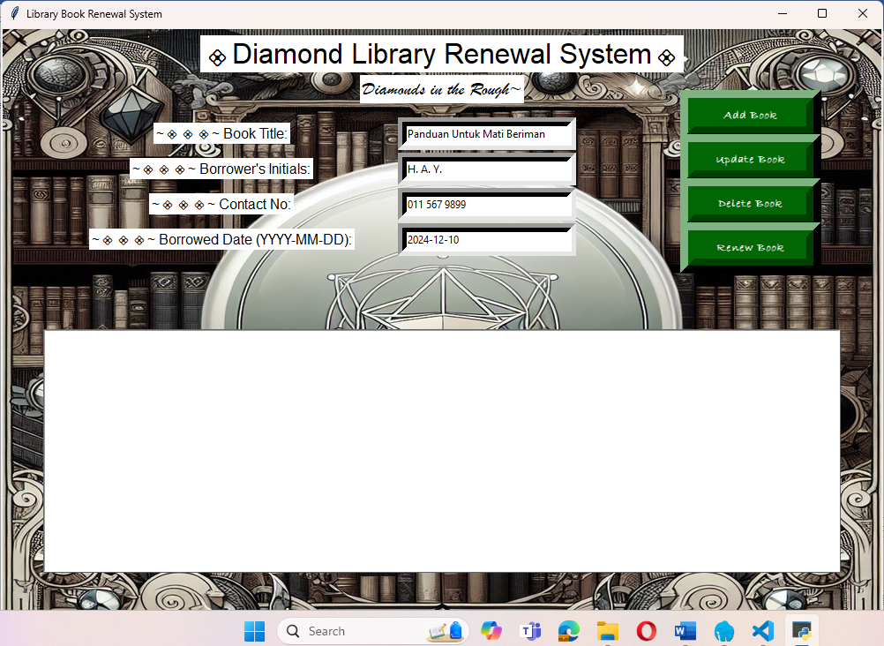

1. Book Renewal

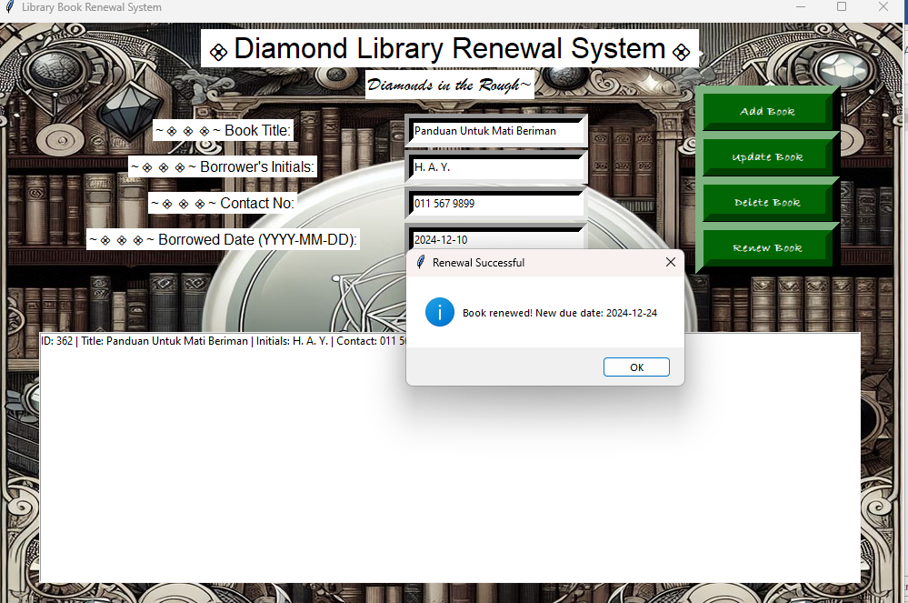

**Conditional Statement : Yes**

If, & else

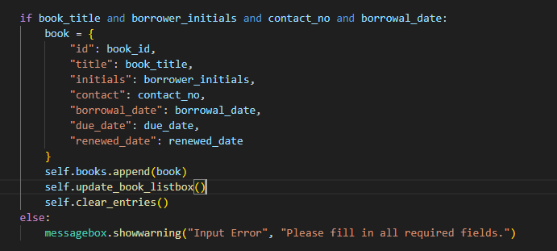

**GUI : Yes(add screenshot)**

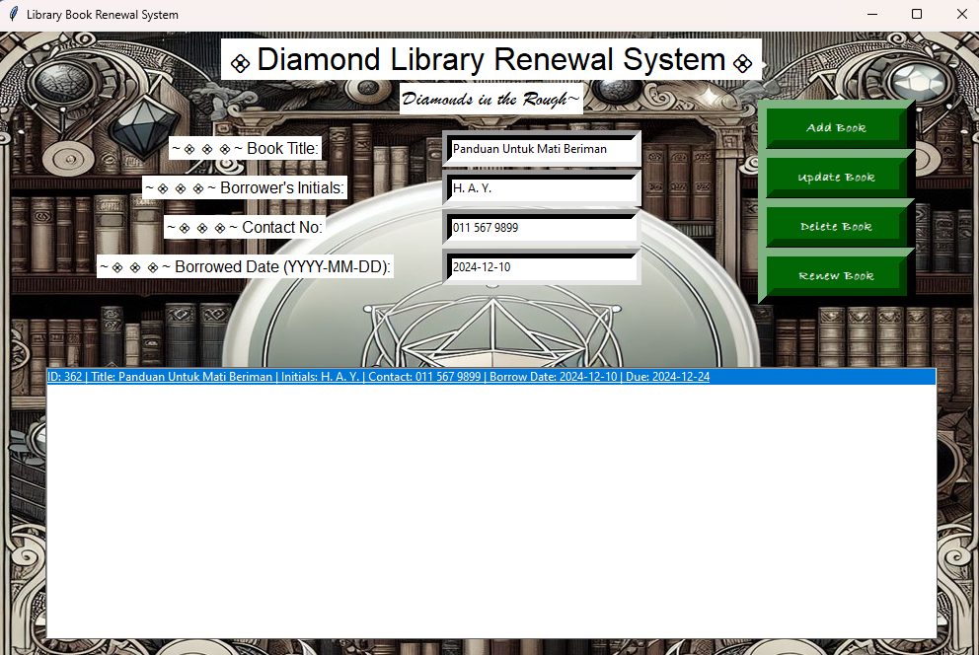

**Result : Screenshot**

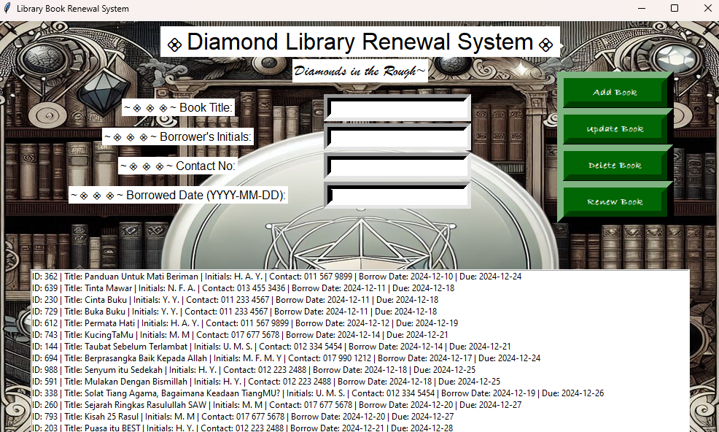

**Strength:**

* Makes it easier for librarian to keep records and renew borrowed books
* Save time of users who wants to renew book
* User-friendly
* Comprehensible, making it easy for even newbies to understand the concept and how to use it.
* Suitable for libraries with small simple collections

**Kaizen (Room for improvement)**

* Can add more details of the book (e.g. author, ISBN, Publisher or any other bibliographic information of the materials)
* Add details of borrowers instead of just their initials
* Add other circulation service like fine due
* Have other functions included (e.g. checking out, checking in, registration)
* Add pictures of the borrowed books